Lab 4: Inserting Initial Data into the Database
Student Name: Aditya Raj 6362534
Lab Title: Lab 4 - Inserting Initial Data using EF Core

Summary
In this lab, we insert initial records into the Categories and Products tables using Entity Framework Core's asynchronous methods (AddRangeAsync, SaveChangesAsync). We’ve also simplified the structure by combining both Category and Product models into a single file.

Step 1: Ensure Project is Ready
dotnet new console -n RetailInventory
cd RetailInventory
dotnet add package Microsoft.EntityFrameworkCore.Sqlite
dotnet add package Microsoft.EntityFrameworkCore.Design

Step 2: Create Models.cs with Combined Models
Create a file called Models.cs and add the following code:
using System.Collections.Generic;

public class Category
{
public int Id { get; set; }
public string Name { get; set; }
public List<Product> Products { get; set; }
}

public class Product
{
public int Id { get; set; }
public string Name { get; set; }
public decimal Price { get; set; }
public int CategoryId { get; set; }
public Category Category { get; set; }
}

Step 3: Create AppDbContext.cs
Create a file called AppDbContext.cs and add the following code:
using Microsoft.EntityFrameworkCore;

public class AppDbContext : DbContext
{
public DbSet<Product> Products { get; set; }
public DbSet<Category> Categories { get; set; }

protected override void OnConfiguring(DbContextOptionsBuilder optionsBuilder)
{
optionsBuilder.UseSqlite("Data Source=RetailDb.db");
}
}

Step 4: Add Initial Data in Program.cs
Replace the contents of Program.cs with the following code:
using System;
using System.Threading.Tasks;

class Program
{
static async Task Main()
{
using var context = new AppDbContext();

var electronics = new Category { Name = "Electronics" };
var groceries = new Category { Name = "Groceries" };

await context.Categories.AddRangeAsync(electronics, groceries);

var product1 = new Product { Name = "Laptop", Price = 75000, Category = electronics };
var product2 = new Product { Name = "Rice Bag", Price = 1200, Category = groceries };

await context.Products.AddRangeAsync(product1, product2);

await context.SaveChangesAsync();

Console.WriteLine("Initial data inserted successfully.");
}
}

Step 5: Create Migration and Apply It
In the terminal, run the following commands to scaffold and apply the database migration:
dotnet tool install --global dotnet-ef
dotnet ef migrations add InitialCreate
dotnet ef database update
You should see messages indicating that the build succeeded and the migration was applied.

Step 6: Run the Application
Run the app with:
dotnet run
Expected output:
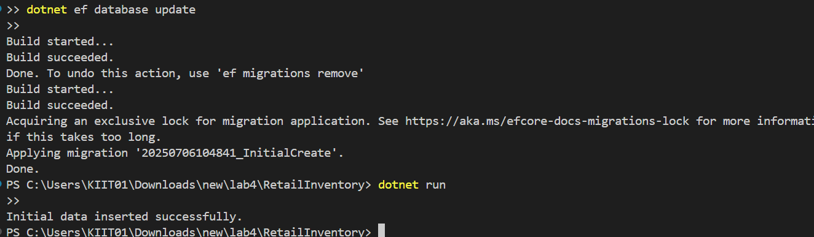

Step 7: Verify the Data
